18. NFA-start with different and end with different.

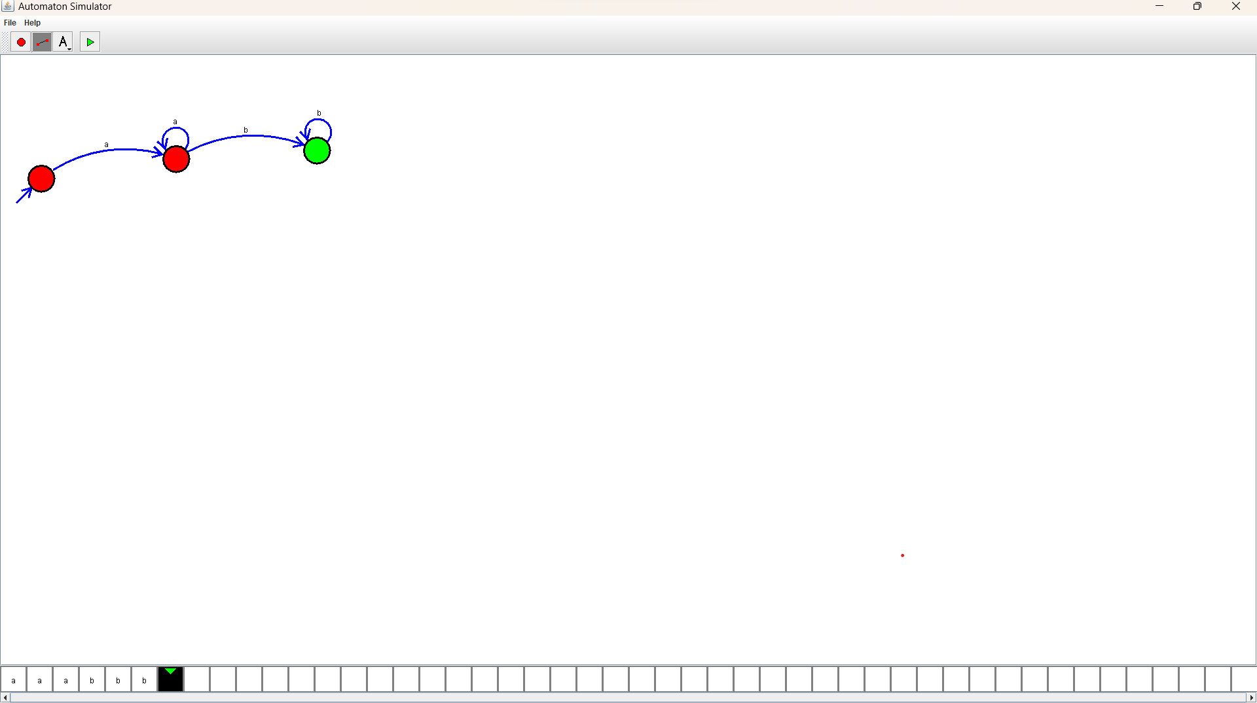Design :

Output:

